OOP Lab 2
1. Define a class to represent a complex number called Complex. Provide the following methods:
  - To assign initial values to the Complex object.
  - To display a complex number in a+ib format.
  - To add 2 complex numbers. (the return type should be Complex)
  - To subtract 2 complex numbers Write a main method to test the class.
Solution:
import java.util.Scanner;
class Complex{
int real,imag;
Scanner sc = new Scanner(System.in);
void read(){
real=sc.nextInt();
imag=sc.nextInt();
}
void display(){
System.out.println(real+" +i"+imag);
}
Complex add(Complex b){
Complex c = new Complex();
c.real=real+b.real;
c.imag=imag+b.imag;
return c;
}
Complex subtract(Complex b){
Complex c = new Complex();
c.real=real-b.real;
c.imag=imag-b.imag;
return c;
}
}

public class Main
{
public static void main (String[] args)
{
System.out.print("Enter the first complex number ");
Complex a = new Complex();
a.read();
System.out.print("Enter the second complex number ");
Complex b = new Complex();
b.read();
System.out.print("The first complex number is ");
a.display();
System.out.print("The second complex number is ");
b.display();
System.out.print("The sum of these 2 complex numbers is ");
Complex c=a.add(b);
c.display();
System.out.print("The subtraction of these 2 complex numbers is ");
c=a.subtract(b);
c.display();
}
}
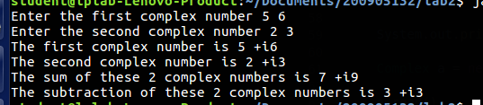
2. Create a class called Time that has instance variables to represent hours, minutes and seconds. Provide the following methods:
- To assign initial values to the Time object.
- To display a Time object in the form of hh:mm:ss {24 hours format}
- To add 2 Time objects (the return type should be a Time )
- To subtract 2 Time objects (the return type should be a Time )
- To compare 2 Time objects and to determine if they are equal or if the first is greater or smaller than the second one.
Solution:
import java.util.Scanner;
class Time{
int hours,seconds,minutes;
Scanner sc= new Scanner(System.in);
void read(){
hours=sc.nextInt();
minutes=sc.nextInt();
seconds=sc.nextInt();
}
void display(){
System.out.println(hours+":"+minutes+":"+seconds);
}
Time add(Time t){
Time sum=new Time();
sum.seconds=t.seconds+seconds;
sum.minutes=t.minutes+minutes;
sum.hours=t.hours+hours;
if(sum.seconds>=60)
{
sum.minutes++;
sum.seconds-=60;
}
if(sum.minutes>=60){
sum.hours++;
sum.minutes-=60;
}
if(sum.hours>=24)
sum.hours-=24;
return sum;
}
Time subtract(Time t){
Time sub=new Time();
int res = this.compare(t);
if(res==0)
{
sub.seconds=0;
sub.minutes=0;
sub.hours=0;
return sub;
}
Time max=new Time();
Time min=new Time();
if(res==1){
max=t;
min=this;
}
else{
max=this;
min=t;
}
sub.seconds=max.seconds-min.seconds;
sub.minutes=max.minutes-min.minutes;
sub.hours=max.hours-min.hours;
if(sub.seconds<0)
{
sub.minutes--;
sub.seconds+=60;
}
if(sub.minutes<0){
sub.hours--;
sub.minutes+=60;
}
return sub;
}
int compare(Time t){
if(t.hours==hours&&t.seconds==seconds&&t.minutes==minutes)
{
return 0;
}
if(t.hours>hours){
return 1;
}
else if(t.hours<hours){
return 2;
}
else if(t.minutes>minutes){
return 1;
}
else if(t.minutes<minutes){
return 2;
}
else if(t.seconds>seconds){
return 1;
}
else {
return 2;
}
}
}
public class Main
{
public static void main(String[] args) {
Time s=new Time();
Time t=new Time();
System.out.print("Enter the first time in 24 hour format ");
s.read();
System.out.print("Enter the second time in 24 hour format ");
t.read();
int res=s.compare(t);
if(res==0)
System.out.println("The 2 times are equal ");
else if(res==1)
System.out.println("The second time is greater than the first ");
else System.out.println("The first time is greater than the second ");
System.out.println("The sum of the 2 times is "+s.add(t).hours+":"+s.add(t).minutes+":"+s.add(t).seconds);
System.out.println("The difference of the 2 times is "+s.subtract(t).hours+":"+s.subtract(t).minutes+":"+s.subtract(t).seconds);
}
}
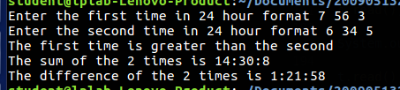

3. Consider the already defined Complex class. Provide a default constructor and parameterized constructor to this class. Also provide a display method. Illustrate all the constructors as well as the display method by defining Complex objects.
Solution:
import java.util.Scanner;
class Complex{
int real,imag;
Scanner sc = new Scanner(System.in);
Complex(){
real=0;
imag=0;
}
Complex(int x,int y){
real=x;
imag=y;
}
void read(){
real=sc.nextInt();
imag=sc.nextInt();
}
void display(){
System.out.println(real+" +i"+imag);
}
Complex add(Complex b){
Complex c = new Complex();
c.real=real+b.real;
c.imag=imag+b.imag;
return c;
}
Complex subtract(Complex b){
Complex c = new Complex();
c.real=real-b.real;
c.imag=imag-b.imag;
return c;
}
}

public class Main
{
public static void main (String[] args)
{
Complex p=new Complex(); // default constructor invoked
Complex q= new Complex(3,5); // parameterized constructor invoked
System.out.print("Complex number created by default constructor is ");
p.display();
System.out.print("Complex number created by parameterized constructor is ");
q.display();
System.out.print("Enter the first complex number ");
Complex a = new Complex();
a.read();
System.out.print("Enter the second complex number ");
Complex b = new Complex();
b.read();
System.out.print("The first complex number is ");
a.display();
System.out.print("The second complex number is ");
b.display();
System.out.print("The sum of these 2 complex numbers is ");
Complex c=a.add(b);
c.display();
System.out.print("The subtraction of these 2 complex numbers is ");
c=a.subtract(b);
c.display();
}
}
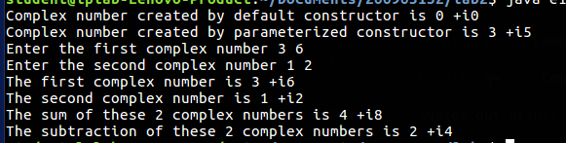

4. Create a class called Counter that contains a static data member to count the number of Counter objects being created. Also define a static member function called showCount() which displays the number of objects created at any given point of time. Illustrate this.
Solution:
class Counter{
static int count=0;
Counter(){
System.out.println("Hello !");
count++;
}
static void showCount(){
System.out.println("The number of objects created currently are "+count);
}
}
public class e4{
public static void main(String[] args){
Counter c1=new Counter();
Counter c2=new Counter();
Counter c3=new Counter();
Counter.showCount();
}
}

